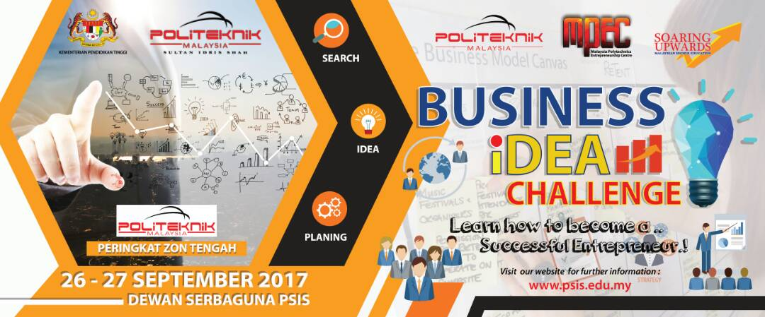
Business IDEA Challenge 2017
REGISTRATION FORM
POLYTECNIC:

NAME | REG NO | TEL
1.
2.
3.
4.

Name (Contact Person): | ________________________________________________
Telephone (HP): | ________________________________________________
Group Name (if applicable): | ________________________________________________
Title of Project: | ________________________________________________
Department: | ________________________________________________
Programme: | ________________________________________________
Email Address: | ________________________________________________
Name of Lecturer/Mentor: | ________________________________________________

*Please submit/ email the registration form to the Secretariat (Unit Keusahawanan) or at keusahawananpsis@gmail.com before 21 September 2017.

